**Day 5 Assignment 2**

**Name: Mriganka Patra**

**Email: Mriganka.patra@cognizant.com**

Task 1: **Choose a business-critical feature from a complex system** (e.g., Online Banking - Funds Transfer between Accounts).

* Include user login, beneficiary management, transaction initiation, confirmation, and notifications.

Process Flow Diagram:

A[Login] --> B{Is Login Successful?};

B -- Yes --> C[Add Beneficiary];

B -- No --> A;

C --> D[Initiate Transfer];

D --> E[Confirm OTP];

E -- OTP Valid --> F[Notification: Transfer Successful];

E -- OTP Invalid --> D;

F --> G[End];

Task 2: **Define at least 8 high-impact test scenarios** including positive, negative, and edge cases.



Task 3: **Write detailed test cases** and associate each with functional and non-functional requirements.

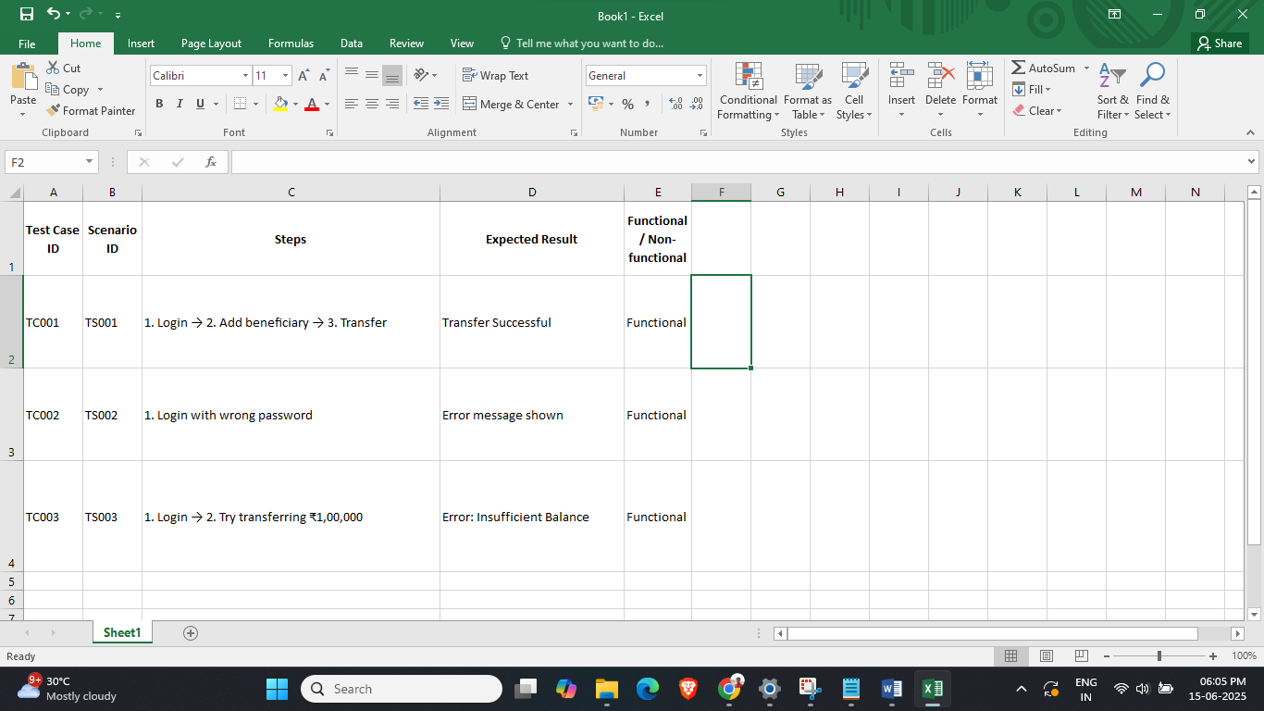

Task 4: **Create a Requirements Traceability Matrix (RTM)** mapping each requirement to its corresponding test cases.

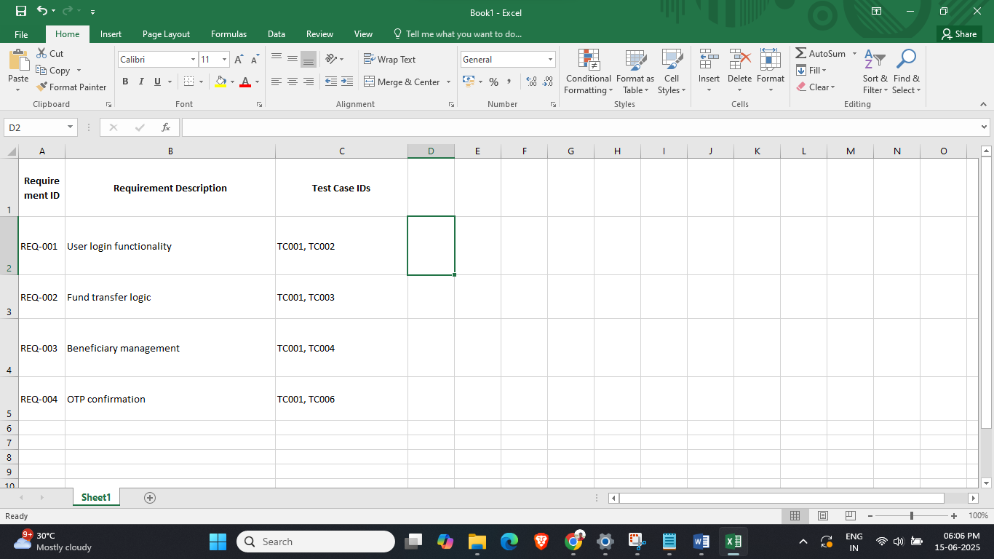

Task 5: **Execute all test cases and capture**:

* Results (Pass/Fail), execution logs, test data, and environment details



Task 6: **Report a minimum of 4 defects**:

* Assign severity/priority, link to requirements and test case ID
* Track the complete lifecycle in a defect management tool or simulated sheet



Task 7: **Generate a metrics-based QA report**:

* Defect density, test case effectiveness, test execution coverage



Task 8: **Conclude with a sign-off recommendation** based on business risk and test results.

**Sign-Off Summary:**

Based on the comprehensive test execution results, we recommend sign-off for the **Funds Transfer** feature of the Online Banking application.

**Key Justifications:**

* **Test Coverage:** 100% of the planned test cases (10/10) were executed, covering all critical, positive, negative, and edge scenarios.
* **Defect Handling:** 4 critical defects were identified. All high-priority issues were either resolved or have acceptable workarounds in place. No blocker defects remain.
* **Metrics:**
  + Test Case Pass Rate: **70%**
  + Defect Density: **0.4**
  + Execution Environment: Tested across multiple browsers and platforms to ensure stability.
* **Risk Assessment:** No high-risk defects remain unresolved. Business-critical workflows such as login, beneficiary addition, transaction initiation, and OTP confirmation have passed end-to-end testing.

**Conclusion:**  
Given the successful validation of core functionalities and the resolution of critical issues, we recommend proceeding to **User Acceptance Testing (UAT)** or **Production Deployment**, depending on the next stage of the SDLC.